|  |  |  |
| --- | --- | --- |
| Reliable backup power and protection for your valuable IT equipment | **Smart-UPS SMT750C with APC SmartConnect, Tower, 750VA/500W**  **Certainty in your connected world**  Protect your servers, switches, routers and networking devices with the Smart-UPS SMT750C with APC SmartConnect – the first cloud enabled UPS for distributed IT. The SMT750C UPS provides backup battery power in the event of a power outage, while safeguarding your equipment from harmful power conditions, spikes and surges. The included service-free cloud monitoring feature is accessible from any internet connected device, and maximizes the life and performance of your UPS by providing proactive advice and life cycle recommendations so you can remotely monitor your power infrastructure from anywhere in the world. Automatic green mode ensures you are operating at the highest levels of efficiency, and intelligent battery management provides real-time monitoring and management through temperature compensated charging that extends the life of the battery. With 500-watt power capacity, six battery and surge protected outlets, and one switchable outlet group, this UPS is ideal for small and medium sized-businesses.  What’s in the Box:   * APC Smart-UPS SMT750C * SmartConnect QR code for simple setup * CD with PowerChute Business Edition Software * Documentation CD * Smart-UPS signaling RS-232 cable * Ethernet cable | LifeIsOn.png  **SMT750C At a Glance:**   * Instant backup battery power during an outage * Protects electronic equipment from harmful power conditions * Six power and surge protected outlets * Proactive remote UPS cloud monitoring that is accessible from any internet connected device * Pure sine wave output on battery * Green mode reduces power consumption and increases energy efficiency * Intelligent battery management and temperature compensated charging * LCD interface with intuitive navigation * SmartSlot for network management card * PowerChute software for safe system shutdown * ENERGY STAR Qualified efficiency * $150,000 equipment protection policy * 3-year warranty on unit and 2-year warranty on battery |

 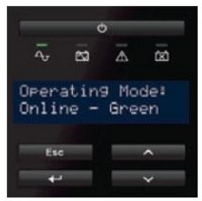 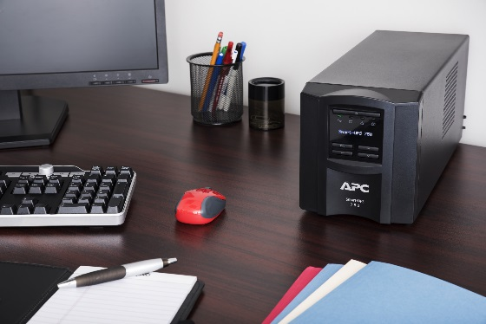

|  |  |  |  |  |
| --- | --- | --- | --- | --- |
| **The first cloud enabled UPS for distributed IT**  The SMT750C comes with our innovative remote cloud monitoring solution, APC SmartConnect, a feature which allows you to view the status of your UPS on a secure web portal via any internet connected device. APC SmartConnect maximizes the life and performance of your UPS through automatic notifications, firmware updates, and advanced support. | **Intuitive LCD interface for status updates and configuration**  The bright, easy-to-read LCD interface provides real-time status updates of your APC UPS with multiple language options, and intuitive navigation keys. | **Intelligent battery management**  For easy maintenance, the Smart-UPS SMT750C provides a predictive month and year when battery replacement is recommended. It also prolongs battery life by regulating the charge voltage in relation to battery temperature. Detect faulty batteries with the periodic battery self-test and disconnected battery notification |  | |
| **Automatic Voltage Regulation (AVR)**  AVR adjusts high and low voltages to a safe level, ensuring your equipment had reliable power and preserving the life of the battery.  **Pure sine wave output**  Pure sine wave output while on battery provides the highest degree of compatibility for active PFC (power factor corrected) servers and sensitive electronics.  **Green mode for reduced power consumption**  Operate efficiently with the Smart-UPS green mode, which allows you to conserve energy without sacrificing any protection when power quality is within optimal levels and power conditioning is not necessary.  **PowerChute software for safe system shutdown**  Designed for exceptional usability, PowerChute Business Edition software provides safe system shutdown in the event of an extended power outage while preventing potential data corruption. Find cost savings by using PowerChute to monitor your equipment’s energy consumption.  **ENERGY STAR Qualified**  Acknowledged for meeting standardized energy efficiency requirements and passing the program's testing, the Smart-UPS SMT750C has been recognized for its ability to save you money while protecting the environment. Any UPS that is ENERGY STAR Qualified much achieve operational efficiency in the top 25 percent of the market, thus demonstrating the ability to allow you to realize lower electrical operating costs, and a reduced carbon footprint.  **$150,000 Lifetime equipment protection policy**  Lifetime connected equipment insurance from the industry leader in power protection.  **Warranty for peace of mind** 3-year warranty on the unit, and 2-year warranty on the battery | | | |